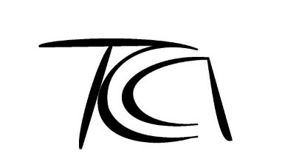

Tasmanian Ceramics Association
Annual Members Exhibition & Prize Giving Entry Form
Theme: Elemental
@ SAC SOCIALGallery
16th until 28th September, 2026

Full Name
Address

State & Postcode
Email Address
Phone
ABN
(or statement which says the work relates to a private recreation pursuit or hobby)
Membership status

Works Submitted
Please note there is a 40cm x 40cm size limit on all entries.
Please let us know if your entry is to be hung

Title of work #1:
Price of work:
(including 20% commission)
Height:
(cms)
Width:
(cms)
Depth:
(cms)
Artist Statement: (maximum of 100 words. This will be displayed with your work)

Further Instructions:

Title of work #2:
Price of work:
(including 20% commission)
Height:
(cms
Width:
(cms)
Depth:
(cms)
Artist Statement: (maximum of 100 words. This will be displayed with your work)

Further Instructions:

Title of work #3:
Price of work:
(including 20% commission)
Height:
(cms
Width:
(cms)
Depth:
(cms)
Artist Statement: (maximum of 100 words. This will be displayed with your work)

Further Instructions:

***Please ensure that you have read the Terms & Conditions.***

Roster Dates and Times –
Please note that you must list at least 2 dates & times for the Gallery Sitting Roster

Please complete this entry form and return to enquiries@tasmanianceramics.com
The TCA will invoice you separately once all Entry forms have been accepted.

Please note that Entry Forms will be accepted up until
the closing of business on Monday 1st September

